**The Battle of the Neighborhoods - Week 1**

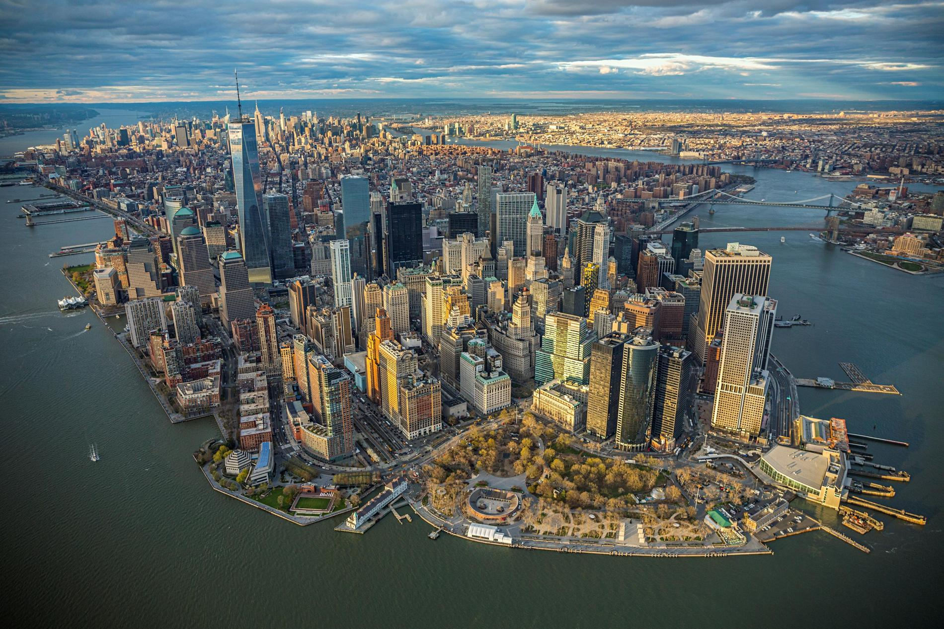

**Introduction**

The City of New York, usually called either New York City (NYC) or simply New York (NY), is the most populous city in the United States and thus also in the state of New York. With an estimated 2017 population of 8,622,698 distributed over a land area of about 302.6 square miles (784 km2), New York is also the most densely populated major city in the United States. Located at the southern tip of the state of New York, the city is the center of the New York metropolitan area, the largest metropolitan area in the world by urban landmass and one of the world's most populous megacities, with an estimated 20,320,876 people in its 2017 Metropolitan Statistical Area and 23,876,155 residents in its Combined Statistical Area. A global power city, New York City has been described as the cultural, financial, and media capital of the world, and exerts a significant impact upon gastronomy, commerce, entertainment, research, technology, education, politics, tourism, art, fashion, and sports. The city provides lot of business opportunities and business friendly environment. It has attracted many different players into the market. New York has emerged as a global node of creativity and and entrepreneurship, social tolerance, and environmental sustainability, and as a symbol of freedom and cultural diversity.

The City of New York is famous for its excellent entertainment, restaurants and for its diversity and is one of the symbols of freedom and cultural diversity. Throughout its history, the city has been a major port of entry for immigrants into the United States and approximately 37% of the city's population is foreign born and more than half of all children are born to mothers who are immigrants.

**Problem and Purpose**

With the all attributes already described, the city also shows a very competitive market. As it is highly developed city, so cost of doing business is also one of the highest. Thus, any new business venture or expansion needs to be analyzed carefully. The insights derived from analysis will give good understanding of the business environment which help in strategically targeting the market. This will help in reduction of risk. And the Return on Investment will be reasonable. As a Brazilian, I would like to explore the city and find the best place to build a new restaurant. The West 46th Street has historically been a commercial center for Brazilians living or visiting New York City. In 1995 the city officially recognized it as "Little Brazil Street" but now, I want to find a different area where I can start a successful business.

The objective is to locate in the city of New York the best location to build a new Brazilian Restaurant, analyzing New York’s boroughs and its neighborhoods, and find the choice to start to build a Brazilian restaurant. The following factors will be considered in order to choose the best location:

1. Cost
2. City demographics
3. Competitors
4. Other venues in the same location
5. Etc.

This can be interest for other entrepreneurs who wants to start a similar business in New York.

**Data**

As previous mentioned, the city of New York and its boroughs will the object of this analyzes. New York City is often referred to collectively as the five boroughs, and in turn, there are hundreds of distinct neighborhoods throughout the boroughs, many with a definable history and character to call their own. If the boroughs were each independent city, four of the boroughs (Brooklyn, Queens, Manhattan, and The Bronx) would be among the ten most populous cities in the United States (Staten island would be ranked 37th).

The following dataset will be used to analyze the demographic aspects of the city of New York:  <https://geo.nyu.edu/catalog/nyu_2451_34572>

Since we were going to on building a new restaurant, we should also analyze the suppliers. In this case, the dataset for the Famers market will also be utilized:

<https://data.cityofnewyork.us/dataset/DOHMH-Farmers-Markets-and-Food-Boxes/8vwk-6iz2>

Other information related to population, demographics and from the city itself, I’ll be using the Wikipedia: <https://en.wikipedia.org/wiki/New_York_City>

This project will also use Four-square API to analyze geographical coordinates and information of other venues for each neighborhood analyzed.

##### Python packages:

• Pandas - Library for Data Analysis

• NumPy – Library to handle data in a vectorized manner

• JSON – Library to handle JSON files

• Geopy – To retrieve Location Data

• Requests – Library to handle http requests

• Matplotlib – Python Plotting Module

• Sklearn – Python machine learning Library

• Folium – Map rendering Library